**Video 7 : Synchronization**

1. synchronized is modifiers is only applicable method and block but not for classes and variables.
2. if multiple thread are trying to operate simultaneously on the same java object then may be chance of **data inconsistency**.
3. to over come this problem we should go for synchronized keyword.
4. if a method of block declare as synchronized then at a time only one thread allowed to execute that method or block given object so that data inconsistency problem will be resolved.
5. the main advantage of synchronized key word is we can resolved data inconsistency problems the main disadvantage synchronized keyword is it is increasing waiting time of thread and creates performs problems hence if there specific requirement then it is not recommend to use synchronized method.
6. Internally synchronization concept implemented by using lock .every object in java has unique lock.
7. whenever we are using synchronized keyword then only lock concept will came into picture.
8. if a thread wants to execute synchronized method on the given object first it has to get lock of the object ones thread got the lock it is allowed to execute any synchronized method on that object.
9. ones method execution completes automatically thread realize the lock.
10. acquiring and realizing lock internally take care by JVM and programmer not responsible for this activity.
11. while a thread executing synchronized method on given object the remaining threads are not allowed to execute any synchronized method simultaneously on the same object but remaining thread are allowed to execute non-synchronized method simultaneously .
12. 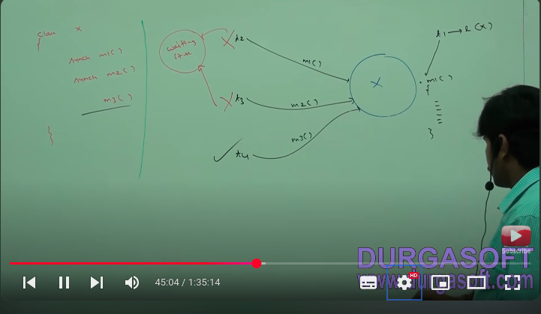
13. lock concept is implemented based on object but not based on methods.
14. 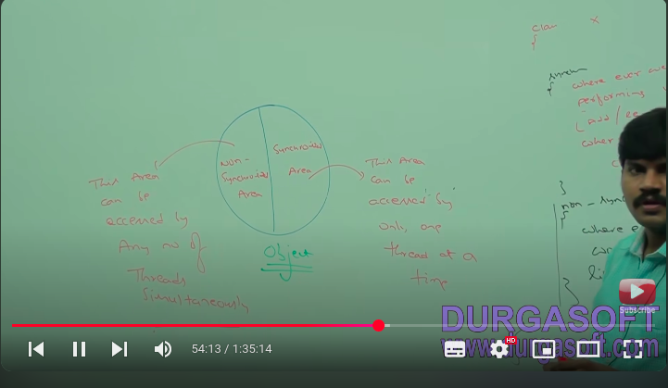
15. 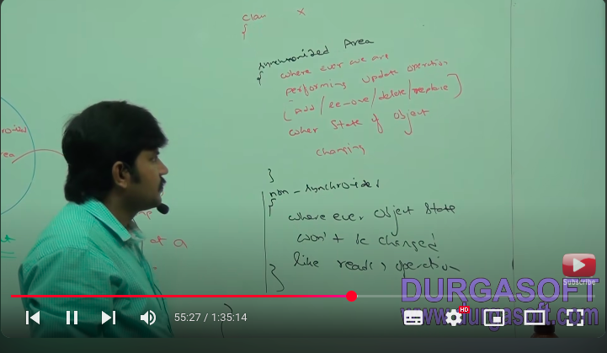
16. **synchronized area -** where ever we are performing update,operation (add,remove,delete,replace) that is where state of object changing .
17. **non-synchronized area -** where ever object state won’t be changed like read operation.
18. 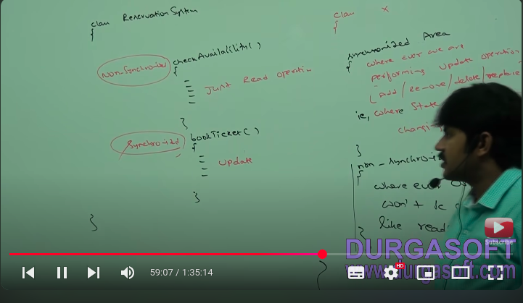
19. Example 1: non-synchronized method
20. 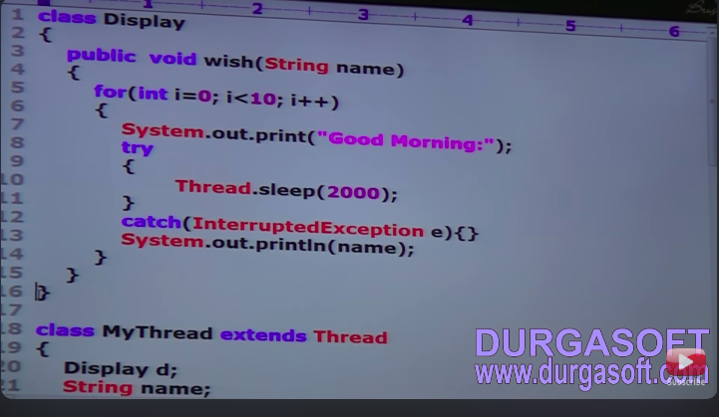
21. 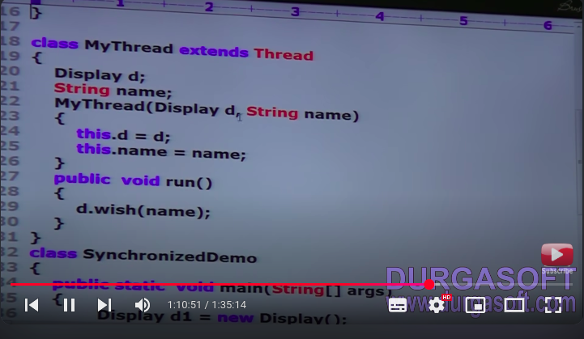
22. 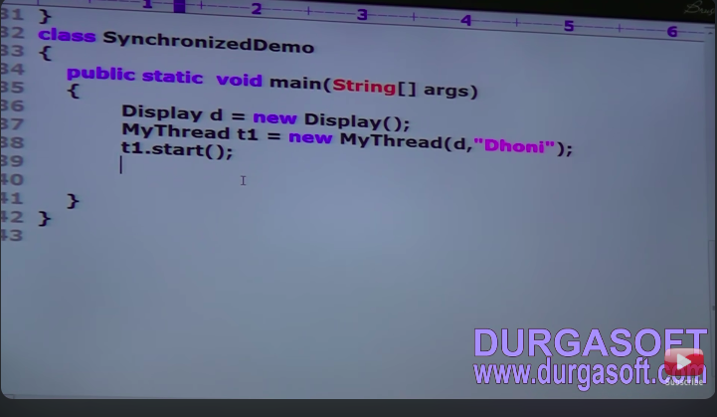
23. 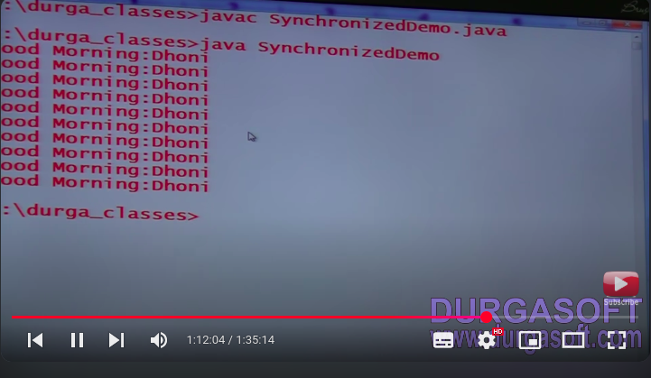
24. example 2 : above program is same but only change in synchronized method - created two thread in below program.
25. 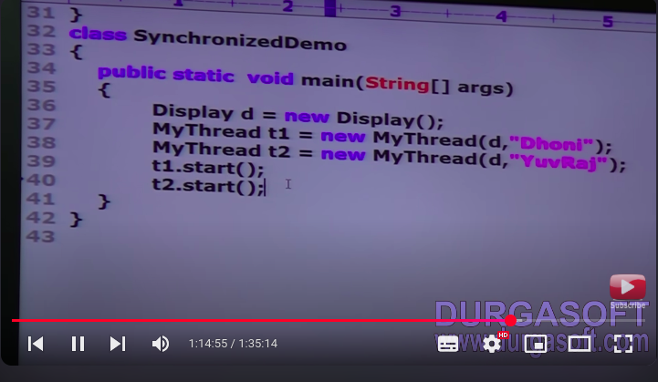
26. 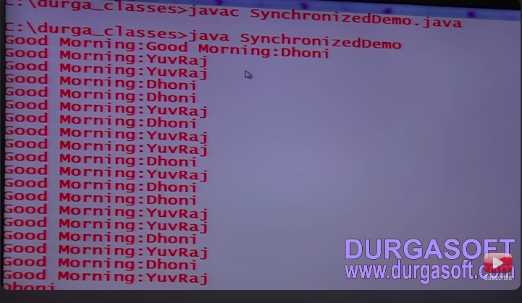
27. because of two thread irregular output is coming.
28. Example 3 : synchronized method
29. 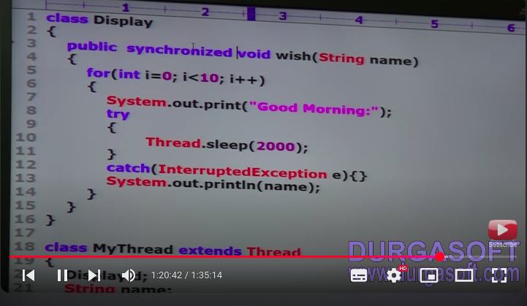
30. 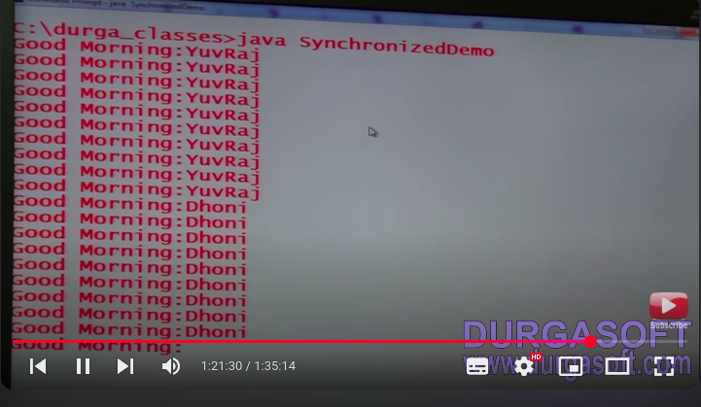
31. because of synchronized method output is coming regular.
32. 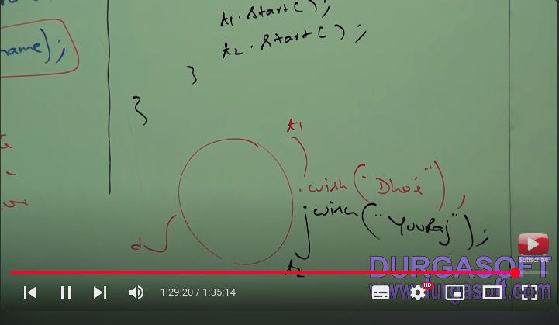
33. in display object t1 calls wish method dhoni as a argument and t2 calls wish method Yuvraj as a argument.
34. **Note :** if not declare wish method as synchronized then both thread will be executed simulteneously and hence we will get irregular output
35. 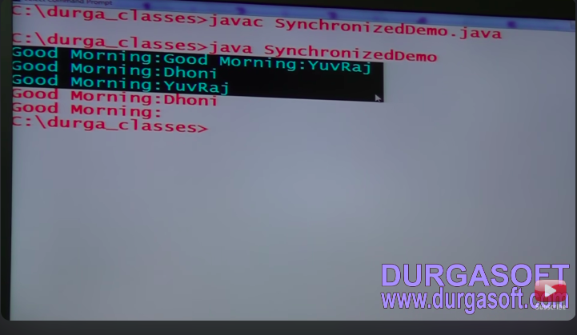
36. if we declare wish method as synchronized then at a time only one thread allowed to execute wish method and t1 display object hence we will get regular output.
37. 

**: Video 8 :**

Case study :

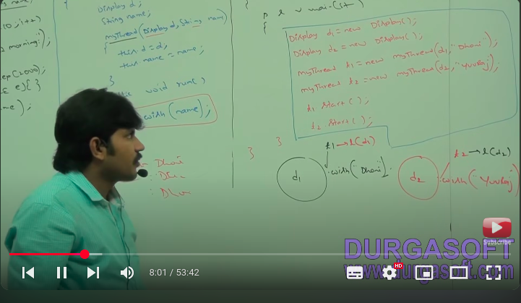

1. even though wish method is synchronized we will get irregular output because thread are operating on different java objects.
2. **Reason/Conclusion :** if multiple thread are operating on same java object then synchronization is required.
3. if multiple threads are operating on multiple java objects then synchronization is not required.
4. class level lock : every class in java has a unique lock which nothing but class level lock.
5. 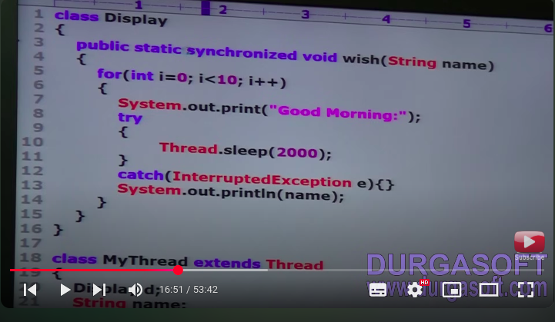
6. if a thread want to execute static synchronized method then thread required class level lock .
7. ones thread got thread level lock then it is allowed to execute any static synchronized method of that class.
8. ones method execution completes automatically thread realizes the lock.
9. 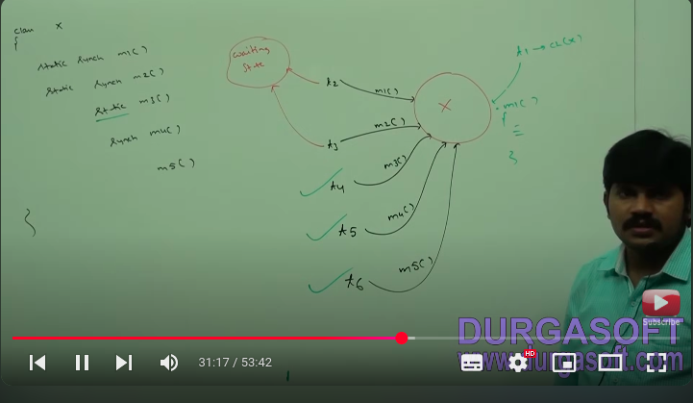
10. while a thread executing static synchronized method the remaining thread not allowed to execute any static synchronized method of that class simultaneously but remaining thread are allowed to execute the following methods simultaneously:
    1. normal static methods
    2. synchronized instance methods
    3. normal instance methods
11. **example 1 :**
12. 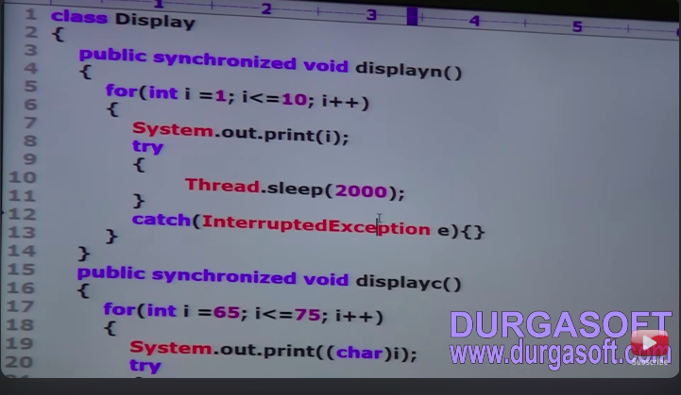
13. 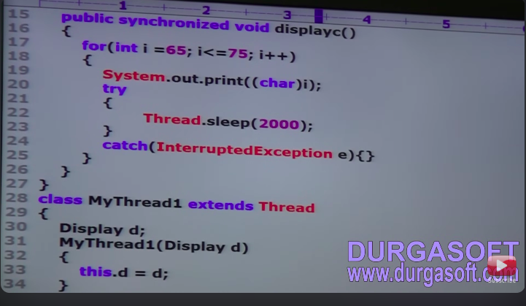
14. 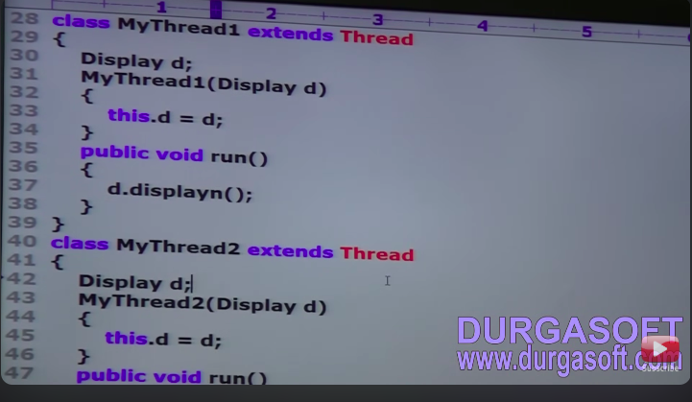
15. 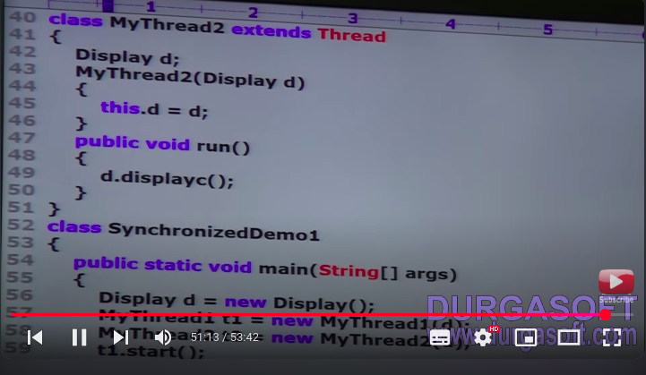
16. 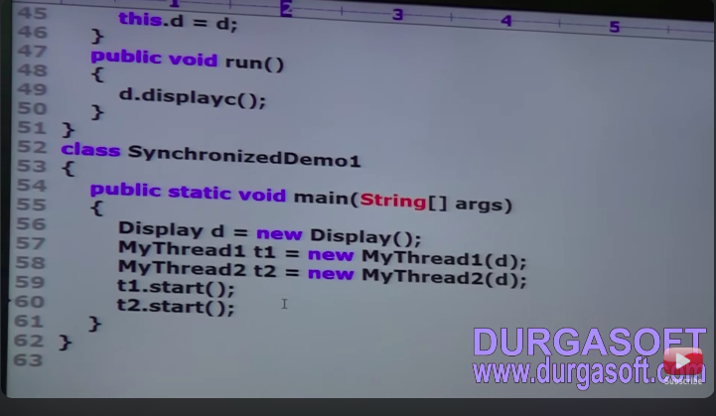
17. 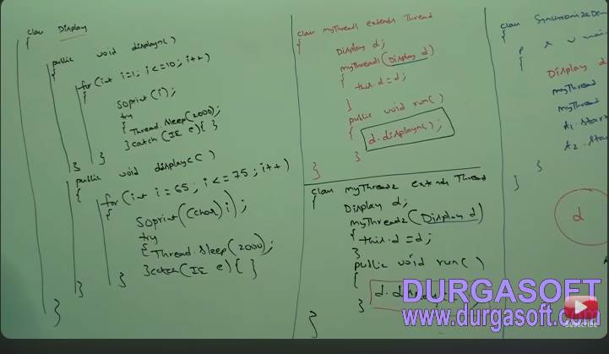
18. 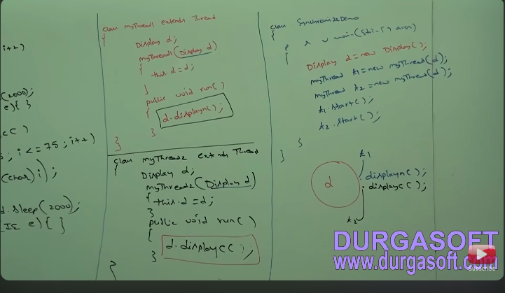

**Video 9 : Synchronized Block**

1. if vary few line of code required synchronization then it is not recommended declare as synchronized.
2. we have include those few line of code by synchronized block.
3. the main advantage of synchronized block over synchronized method is it is reduces waiting time of thread and improve performs of application/system.
4. we can declare synchronized block as follow:
5. 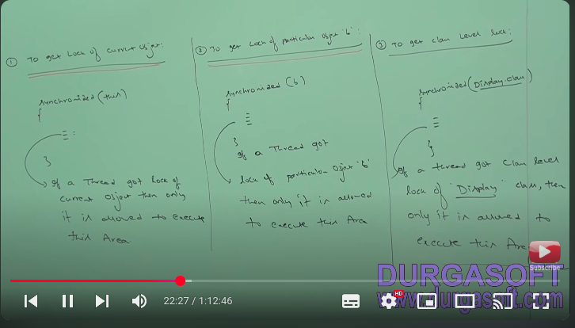
6. example 1 : synchronized block
7. 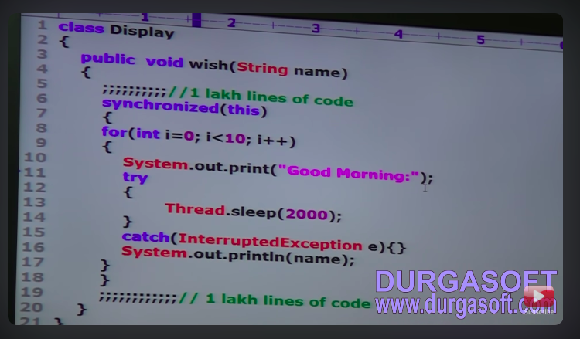
8. 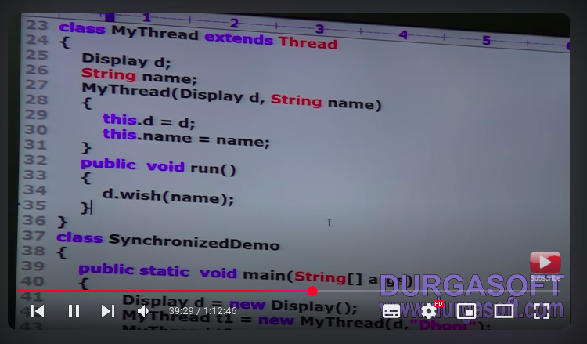
9. 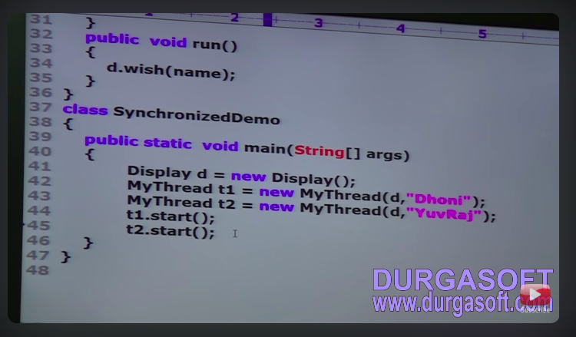
10. example 2 : class level lock
11. 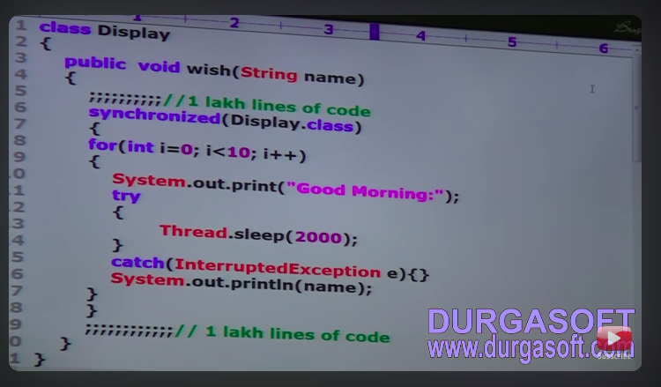
12. **Note : change in synchronized method added parameter Dispaly.class**
13. **Example 3 : in synchronized method passing primitive type value**
14. 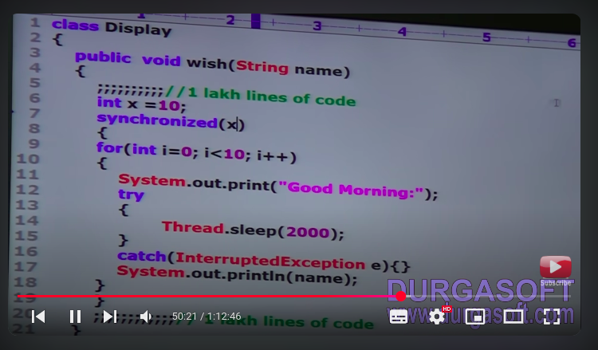
15. 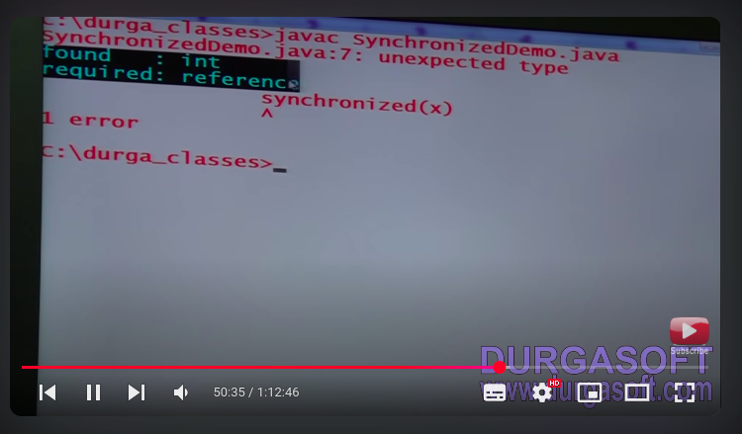
16. lock concept applicable for object and class types but not for primitives hence we can’t pass primitive type as argument to synchronized block other wise we will get compile time error saying unexpected type fond in required reference.
17. **important question about synchronization :**
18. 
19. **What is Race condition?**
    1. if multiple threads are operating simultaneously on same java object then there may be chance of data inconsistency problem this called race condition.
    2. we can over come this problem by using synchronized keyword.
20. while a thread synchronized method on given object is remaining thread are allowed to execute any other synchronized method simultaneously on the same object.
    1. **NO**
21. **what is synchronized block?**
22. **how to declared synchronized block to get lock of current object?**
23. **how to declared synchronized block to get class level lock?**
24. **what is advantage of synchronized block over synchronized method?**
25. **is thread can acquired multiple lock simultaneously?**
    1. **yes..**